Landscape Architecture Program LDA 3: Sustainable Development, S 2017
Department of Human Ecology Prof. Stephen M. Wheeler, Ph.D.
University of California, Davis smwheeler@ucdavis.edu; (530) 754-9332

EXERCISE
CREATING A SUSTAINABLE ECONOMIC DEVELOPMENT STRATEGY

Congratulations! Your consulting firm has been hired to produce a green economic development strategy for a Bay Area city interested in being more sustainable. Info about your particular city will be handed out separately. Based on this information and what you know of the region and sustainability planning, your firm must come up with a strategy for the mayor and city council.

This strategy should include:
- A recommendation on particular types of business or industry the city should focus on
- Particular incentives, programs, or regulatory changes by which the city might support these
- Land use and urban design changes that can complement these forms of economic development

Develop an overall theme if possible. Consultants like to come up with catchy phrases that label a particular strategy. (Berkeley for example has had a “Green Valley” program to promote eco-businesses, in contrast to “Silicon Valley.”) Short, punchy concepts will be easy for the city council to understand and prevent them from going to sleep. Be as visionary as you like, but back up your recommendations with pragmatic suggestions for how these can be implemented.

Some Potential Economic Development Strategies
-- Business recruitment: City tax breaks and subsidized infrastructure or land to lure businesses from other cities (a traditional strategy). Be prepared to say what types of businesses you think you could reasonably get, and why those industries would be sustainable.
-- Business retention: Support for existing businesses in the form of loans, technical assistance, and efforts to help them find larger spaces within the city. But what types of businesses would you retain?
-- Microenterprise development: A special focus on small start-up companies to help them get going, often through loans, technical assistance, and subsidized office space and services within a business incubator (a building with flexible office space and shared facilities)
-- Eco-business development: A focus on environmentally protective and restorative types of businesses (recycled products; pollution control and cleanup, alternative energy, alternative building materials)
-- Eco-industrial parks: A strategy to link industrial and manufacturing businesses so that they can use one another’s waste products as inputs
-- Local self-sufficiency: A strategy emphasizing locally owned businesses using local labor and providing products and services for local markets. Might imply policies to keep out chain stores and big-box retailers.
-- Cooperative businesses: Support for worker- or consumer-owned businesses.
-- Conservation-based development: Efforts in rural areas to support sustainable resource production and agriculture
-- (Eco)Tourism: Takes advantage of environmental amenities and cultural heritage as economic assets (implies support for historic preservation, park, and sustainability programs).
-- Place-oriented strategies: Focus on creating centers or hubs of economic activity that will then generate further economic growth, for example by creating 24-hour downtowns that attract entertainment-related businesses.
CITY 1

Richmond

(An older industrial city)

Your city has definitely seen better days. Its boom period was during World War II, when massive federal investment in shipbuilding, munitions, and petrochemicals fueled the city’s growth. Large numbers of African American workers moved from the southern U.S. to labor in these war industries. During this period Richmond was one of the most rapidly growing cities on the West Coast. After the war shipbuilding declined, and many white middleclass residents left the city. A large Ford assembly plant closed in the 1960s, and still sits rusting on the waterfront, along with remnants of the World War II Kaiser shipyards. The city recently created a “Rosie the Riveter” museum to use some of these facilities. One portion of the waterfront has been redeveloped into an upscale marina/housing community, and other parts of the waterfront have potential for development as marinas, parks, business sites, or housing. But is upscale waterfront development most sustainable approach?

The city is well-served by rail transportation, being on the main Union Pacific and Amtrak lines. It is home to several oil refineries and a number of new warehousing and biotech companies which the city has been encouraging to locate along 580 near the waterfront. Companies like Safeway see Richmond as a centrally located distribution point. However, this land is limited, infringes on fragile ecological areas next to the bay, and is isolated from downtown. Richmond’s downtown has suffered from decades of disinvestment and despite great access to BART has empty storefronts and many sites that are waiting for redevelopment. Hilltop Mall has been a retail success story but has drained business from the downtown. Neighborhoods such as the “Iron Triangle” (just west of downtown) are home to a low-income population with entrenched social problems. Meanwhile, middle-class whites cluster in the Richmond Annex across I-80 at the east side of the city.

The tax base of Richmond is not high compared to service needs. Residents and city council members are desperate for economic development and are willing to try a greater range of options than other more conservative communities. The port has also done better in recent years, in part as a transshipment point for the transport of scrap metals to Asia for recycling. The transit hub where BART and AMTRAK come together offers an opportunity for transit-oriented development, and indeed a transit village is being planned at the Richmond BART station, although people have criticized the first stage of this for focusing on relatively low-density townhouse housing.

More land can be made available for industry by the waterfront if the city is willing to spend the money to take down old rusting buildings and clean up their sites. But many city roads, sewers, stormdrains, and other infrastructure are old and need additional investment.

Your challenge as consultants is to figure out a way that this older city can begin to repair its infrastructure and rebuild its vitality in a way that doesn’t cost much and is sustainable.
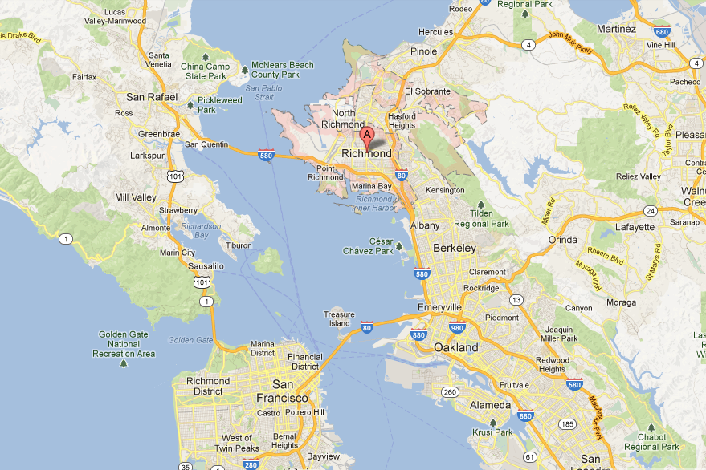
CITY 2

Dublin

(A new, rapidly-growing suburb)

You are in the envious position of being one of the Bay Area’s most rapidly growing and best-funded cities. New business parks, automobile dealerships, and big box retail along 580 are bringing in enormous tax revenues. Your population is still small (around 55,000) and presents relatively low demands for schools and services. It is also a fairly affluent population. There is very little cheap housing in your city, so you don’t have to worry much about providing services for poor people.

Dublin is well served by freeways and two BART stops (one open now, one in the future), and businesses are relatively eager to locate there. The city now has the luxury of deciding what types of businesses it wants to recruit, with a fair degree of confidence that it can get some of these. The city has a highly educated workforce. Leading employers at the moment are Sybase, Pacific Bell, MicroDental Laboratories, E-Loan, and two medical equipment labs—high-tech or service-oriented companies.

The BART stations offer the potential for transit-oriented development. Otherwise, the city controls approximately 2,000 acres of former ranch land that it can zone for business, housing, retail stores, or some combination of the two. But once this land is built out in ten or fifteen years, the city will have little more room for development. To a large extent it will be stuck with the land use and economic development decisions it makes now.

Dublin has little history and in fact did not exist before 1982. Its main current problems include traffic congestion on the 580 and 680 freeways, relatively high levels of per capita greenhouse gas emissions, a lack of affordable housing for service workers including teachers and nurses, and the lack of a downtown or other civic places. The city could potentially create these, but must decide on the best location and a combination of public investments and planning that would make it happen.

The city’s political leadership is conservative and strongly pro-growth, though enough councilmembers have environmental leanings that they were able to get the sustainable development consulting contract approved. Your task as consultants is to show these politicians how they can have sustainable development without jepardizing long-term tax revenues. Luckily you have a lot of resources to work with in the near term.
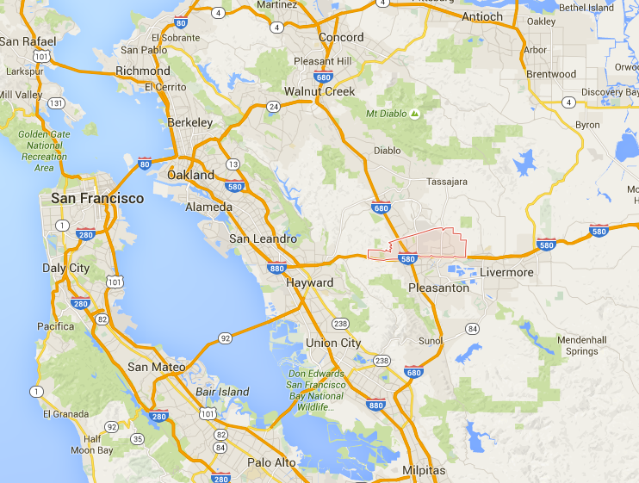
Dublin
CITY 3

SAN LEANDRO

(An older, inner-ring suburb)

San Leandro is an older East Bay suburb that developed primarily in the 1950s and 1960s but has stagnated somewhat in recent years. Although it has nowhere near the social problems and social service needs of neighboring East Oakland, it still has a sizeable and increasingly diverse lower income population, in addition to many middle class residents, and is struggling a bit to maintain the quality of its library and school system.

Many city leaders believe that the city's land area is relatively built out, and worry that the city will enter a period of decline as older industries stagnate. However, by the same token new development opportunities have emerged because some older warehouse businesses near 880 have gone out of business, and remnant agricultural lands occupied mainly by greenhouse operators have now come on the market. There have also been some vacant lots near downtown and BART for many years. The city is situated on what was once some of the best farmland in the Bay Area, and a cherry festival is still held annually to celebrate what was once the city’s leading crop.

The city’s existing economic base consists of warehouse and distribution facilities near the 880 freeway, a number of small, older manufacturers, and the usual assortment of service businesses serving the local population. Several older shopping centers built in the 1940s and 1950s are slowly declining. The city has considered trying to develop a new mall and recruit a large big box retailer such as Ikea, but more entrepreneurial cities such as Emeryville and Milpitas have beaten it to the punch.

Your job as consultants is to recommend strategies for the city that might make best use of its strengths—including a central Bay Area location, good rail and highway transportation, redevelopable sites, a functional though underdeveloped downtown, and a relatively educated middle class population—without costing enormous sums. The city isn’t broke, but neither is it rich, and city leaders are worried about the future.

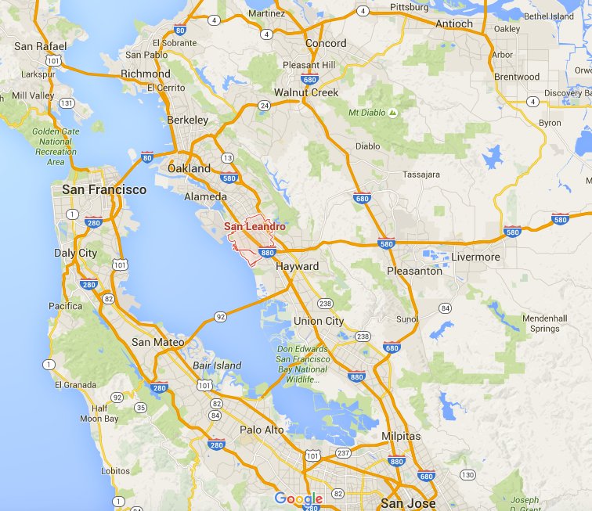
CITY 4

TRACY

(A new but lower-income exurb)

Your city is the epitome of the Central Valley boomtown created by spillover from Bay Area growth. For the past 15 years your planners have been approving permits for new houses as fast as they can, and population has exploded (and is now 83,000). Tens of thousands of middle and working class residents now live in new subdivisions in Tracy and commute over the Altamont Pass to jobs in the Livermore, Pleasanton, Fremont, and Silicon Valley. There is also a sizable Latino population (27%), many of whom are Central Valley farmworkers.

The city has also issued bonds to help fund new infrastructure, which must be paid off in the future. While this economic and housing boom continues the city takes in a lot of money from permitting fees for new development (around $30,000 per house). But once building stops, this revenue stream will dry up, and the city will be stuck providing services for residents who will demand schools, parks, libraries, fire and policy protection, and many other benefits. They won’t be too happy paying higher taxes for these things either.

Much of the city’s problem is that it is almost entirely residential. This was a small farm town until twenty years ago, and there is little economic base to balance all the housing tracts and to contribute a stable stream of tax revenue. The city’s main businesses are food products businesses related to its agricultural past, plus a few warehousing businesses, some few automobile and truck dealerships, fast food restaurants along the main arterials, and a modest number of chain stores downtown.

Among the city’s main assets are its rich farmland (now mostly covered by houses), its cheap land (ditto), a “small town atmosphere” that is rapidly disappearing, and a large number of stay-at-home spouses who might potentially serve as a cheap labor pool for new local enterprises allowing workers to do part-time or flex-time work.

The city leaders are suddenly nervous about the long-term economic and financial sustainability of their city. Your job is to given them recommendations on how the city might develop more sustainably—ensuring a reliable local tax base as well as environmental, social, and economic well-being. The city’s current theme (“The Place to Live Your Future”) is getting tired; a new strategy is needed.
