Landscape Architecture Program LDA 3: Sustainable Development, S 2017
Department of Human Ecology Prof. Stephen Wheeler, Ph.D.
University of California, Davis smwheeler@ucdavis.edu; 530-754-9332

In-Class Exercise:

Understanding Different Perspectives on a Sustainability Issue

In this exercise, we will role-play a mediated negotiating session between different stakeholders on the proposed Cape Wind Project in Nantucket Sound near Cape Cod, Massachusetts. A decade in process already, this project would place 130 large three-megawatt wind turbines, each 400 feet high, across a 24-square-mile-area about five miles offshore. This place has the best wind anywhere in New England. The turbines would supply up to ¾ of the Cape region’s electricity, but would be visible on the horizon from the summer homes of some very wealthy people, and may affect fishing, boating, and Native American spiritual activities. It is not possible to move the wind farm further offshore and still have the best wind.

In this scenario, the state’s Governor has sent a high-level mediator to work with various parties to see if consensus can be developed around a revised project to avoid further lawsuits. The mediator will run the meeting. She should 1) have the participants introduce themselves, 2) ask them to make proposals for changing the project in ways that would be acceptable to them, 3) make sure everyone speaks and no one dominates, and 4) identify areas of common ground and write them down. See if you can reach consensus within the group.

Read your character’s description and act out this character as dramatically as you can. There will be a prize for best actor/actress in each group. Try to understand how each character sees the world in terms of their values, their assumptions, and their overall worldview.

Roles:
Joanne Bromwich, Asst. Secretary, Massachusetts Office of Energy and Environmental Affairs
Audra Parker, President and CEO of The Alliance to Protect Nantucket Sound
David Scudder, Vice President, Hy-Line Cruises

Bettina Washington, Wampanoag Tribe of Gay Head/Aquinnah
Jim Gordon, President, Cape Wind
Kerk Davies, Research Director, Greenpeace
Edward Barrett, President of Massachusetts Fishermen's Partnership

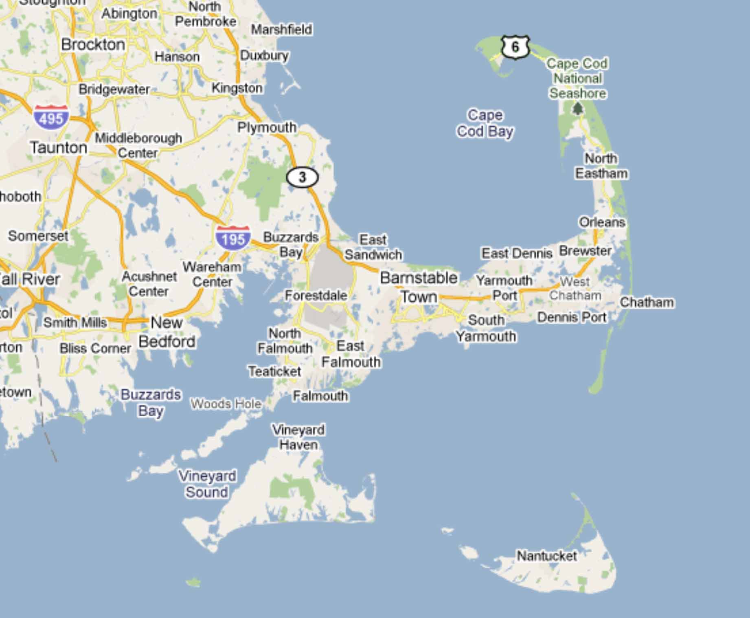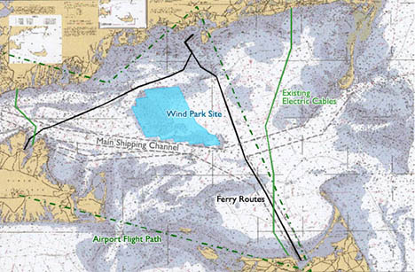

Joanne Bromwich
Assistant Secretary, Executive Office of Energy and Environmental Affairs

You are a 47-year-old state official holding a high-ranking appointed position in this cabinet agency. You have been sent by the governor to see if you can facilitate agreement between many of stakeholders in the Cape Wind debate. A lawyer, you have special training in facilitation, crisis management, and mediation, and are a calm and patient person. Having lived in six countries and mediated scores of disputes, you are usually able to understand all sides and help different groups understand one another.

As facilitator, your role in this meeting is not to state your own opinions, but to make sure all the other participants get to state their views, to make sure none of them dominate the discussion, to suggest possible alternatives and points of agreement, and to take careful notes of those points of agreement.

Audra Parker
President and CEO of the
Alliance to Protect Nantucket Sound

You are the leader of a coalition of local environmental groups who feel that the construction and operation of the wind farm will harm water quality, wildlife (mainly birds), and views. You view the wind farm as “industrialization” of this scenic area, and think this will undermine quality of life for residents. There must be some other place to put such things, you think, where they will affect fewer people. You believe that the people of any local community should have the right to decide what gets built there. Your group has filed a lawsuit to stop the project. You are angry that local people weren’t consulted earlier.

A native of the area, you live in a large house on the coast with your four children, and enjoy racing your sailboat in the future wind farm area with other wealthy families such as the Kennedys. You hold an MBA from the MIT Sloan School of Management and a Bachelor of Science in Applied Mathematics and Economics from Brown University. You have 20 years of experience in strategy and business management and have consulted to a wide range of industries on how to efficiently run a business.

You might be willing to drop your opposition if the project was much farther offshore and much smaller…but there would still be the problem of the wind turbines getting in the way of sailboat races.

Having done quite a bit of reading on the topic, you’ve also embraced the idea that small-scale, decentralized energy systems are the most sustainable way to go, rather than huge wind farms, and have “walked the walk” by putting solar panels on your own house.

David Scudder
Vice President, Hy-Line Cruises

You are a 38-year-old graduate of the Business School at Boston University, and help run your family’s very profitable business that operates cruise boats in Nantucket Sound and around the islands of Martha’s Vineyard and Nantucket. As a small business owner you believe in private enterprise and the free market, and joined the Tea Party in 2008. You believe that government should stay out of people’s business and that the only legitimate role for government is to provide foreign policy and military defense for the country.

For years you and your company have fiercely opposed the Cape Wind Project, calling it a “hazard to navigation” and “a recipe for disaster.” But in early 2013 Cape Wind offered your company a partnership in “eco-tours” of Nantucket Sound in which tourists would be shown the wind turbines up close. They made a convincing case that there was money to be made. You have now switched sides, and support the project as a great business opportunity, not just for yourself of course but for other businesses on Cape Cod.

Bettina Washington
Aquinnah Wampanoag Tribe

You are a 64-year-old former daycare worker who now works as a volunteer representing the tribe in public policy forums. The Aquinnah Wampanoag tribe was displaced by whites in the 1700s and almost disappeared, but in 1972 a small group of descendents came together to re-form the group. In 1987 the federal government helped the tribe acquire 495 acres of land at one end of Martha’s Vineyard, and the tribe now has 1121 members.

You believe that the 130 wind turbines over a 24 square mile area will block views across the sound, disturb ancestral burial grounds, and perhaps disturb cultural relics. Constructing the foundations for the wind turbines could mean literally digging in your ancestors’ bones. Tribe members tend to see this project as just another in a long line of efforts by whites to take over the Earth for their own purposes, disrespecting history, tradition, and the Earth itself in the process.

You recently told The New York Times, “Here is where we still arrive to greet the new day, watch for celestial observations from the night sky, and follow the migration of the sun and stars in change with the season.”

Jim Gordon
President, Cape Wind

You are a 54-year-old entrepreneur who founded the parent company of Cape Wind in 1975, and has made a career of developing alternative energy projects. You believe strongly in the ability of progressive businesses to make a difference in the world, but see government intervention in markets and local politics as essential to help “level the playing field” so that eco-businesses can compete with traditional corporations and avoid opposition from wealthy local interests. Cape Wind is your largest and riskiest project to date.

Among your arguments for the project:

- Cape Wind will reduce greenhouse gas emissions by 734,000 tons/year.
- It can supply ¾ of electricity used in Cape Cod and the islands.
- It will contribute to improved air quality in New England by replacing older coal and oil-burning power plants.
- It can stabilize electricity prices through fixed, long-term contracts not dependent on the price of oil.
- The project will create 1,000 jobs in assembly and construction, and 150 permanent jobs.
- The project will reduce regional electricity prices by $7.2 billion over 25 years, according to a study you commissioned by the Charles River Associates, a research firm
- The project will establish the area as a worldwide leader in renewable energy.

Kerk Davies
Research Director, Greenpeace

You are a 28-year-old graduate of U.C. Santa Cruz who has worked for Greenpeace for five years. Like others in your organization, you believe that the future of the Earth and its creatures is by far the foremost concern currently, and that a variety of creative, non-violent actions may be required to oppose unsustainable practices. Personally you try to live simply, in a cooperative household in Washington, D.C., and pride yourself on having a hip, low-impact lifestyle. But as a representative of an international environmental organization you log 200,000 miles of air travel a year to visit projects all over the world.

Greenpeace has actively supported Cape Wind since it was first proposed in 2001, and has organized a coalition of 122 national environmental and energy organizations that is asking President Obama to approve it.

Quote: “There could be no clearer direction for America's energy future and global warming leadership, and Greenpeace is calling upon President Obama to rethink his plans to open the door to more risky offshore drilling and to prioritize renewable energy projects like Cape Wind instead."

Edward Barrett
President, Massachusetts Fishermen's Partnership

You are a 48-year-old commercial fisherman who fishes Nantucket Sound in the fishing boat Sirius, and prides himself on being a crusty, down-to-earth, no-nonsense guy. Since you were a teenager you have caught flounder and haddock in these waters, and you see fishing as a vital industry with an ancient tradition that is now under assault from many sides, including government regulation, fluctuating prices, decline of fishing stocks in the ocean, and now this wind farm.

You and the statewide organization that you’re president of are concerned that these very large turbines will disturb radar and navigation, and will make fishing impossible in much of the Sound. Radar is essential for safety, since fog often means that boats cannot navigate by sight. It would also be difficult for fishing boats to drag nets between these large windmills situated one-third of a mile apart.

